43.76: a) A least-squares fit of the log of the activity vs. time for the times later than 4.0 hr gives a fit with correlation 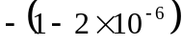 and decay constant of 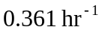, corresponding to a half-life of 1.92 hr. Extrapolating this back to time 0 gives a contribution to the rate of about 2500/s for this longer-lived species. A least-squares fit of the log of the activity vs. time for times earlier than 2.0 hr gives a fit with correlation = 0.994, indicating the presence of only two species.
b) By trial and error, the data is fit by a decay rate modeled by
.
This would correspond to half-lives of 0.400 hr and 1.92 hr.
c) In this model, there are 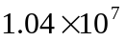 of the shorter-lived species and 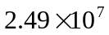 of the longer-lived species.
d) After 5.0 hr, there would be 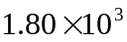 of the shorter-lived species and 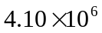 of the longer-lived species.

